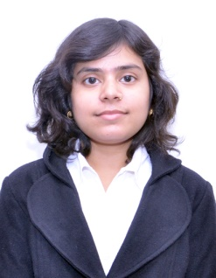

**SHRUTI**

**Mobile No:8860507734 ; E-Mail**: shrutishastri13011993@hotmail.com

**Education**

*Professional Qualifications*

* Pursuing MBA from Banarsidas Chandiwala Institute Of Professional Studies (I.P. University) , New Delhi
* Percentage of Ist Semester 75%, IInd Semester 79%

*Academic Qualifications*

* Bachelor in English (Hons.) 2010-2013 from Swami Shraddhanand College, Delhi University 52.18%
* Higher Secondary School 2010 from S.K.V. No.1, Gandhi Nagar, Delhi 61.25%
* High School 2008 from S.K.V., Shankar Nagar, Delhi 72%

**Relevant Subject**

* Retail Management
* Marketing Management
* Sales and Distribution Management
* Consumer Behavior

**Achievements**

* Won two 1st Prizes in Management Games in Jaipuria Institute Of Management in 2014
* Won 1st Prize in Creative Writing in (S.S.N. College) Delhi University in 2013
* Participated in Business Plan in Delhi Institute of Advanced Studies in 2014
* Participated in poetry recitation and debate competition in Delhi University in 2012
* Won Punctuality and Regularity Award in BCIPS (2013-2014)
* In Placement Cell of BCIPS
* Internship in Real Estate firm (Felicity Group) for 2 months

**Skills**

* Leadership Skills (Class Representative)
* Communication skills
* Confident Person
* Creativity Skills

**Language**

* English
* Hindi

**Personal Details**

* **Date of Birth** **:** 13 January 1993
* **Permanent Address** **:** X/3103, Street No.-4, Raghubar Pura No.-2, Gandhi Nagar, Delhi-110031